WIRELESS NETWPORK:
OPEN WIRELES ROUTER AND SELECT
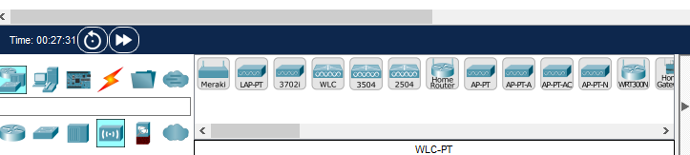
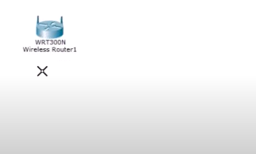
LETS ADD 3 PCS OR PCS ACCORDING TO YOUR NEED
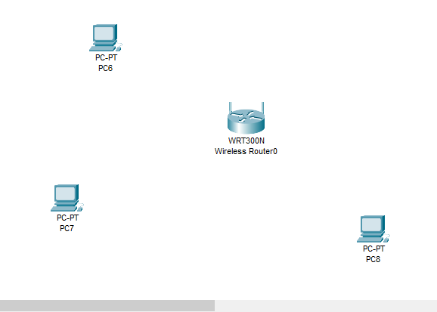
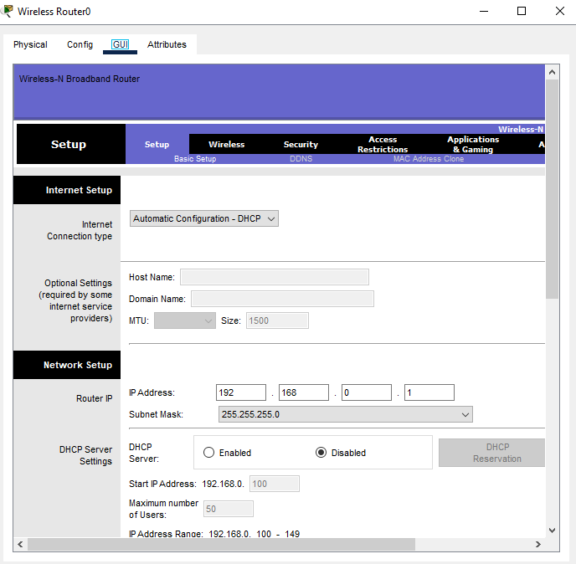
DISABLE DHCP AND SAVE SETTINGS:
AFTER THAT CLICK AT WIRELESS ALL THE SETTINGS WILL BE SAME I JUST CHANGE NETWORK NAME:
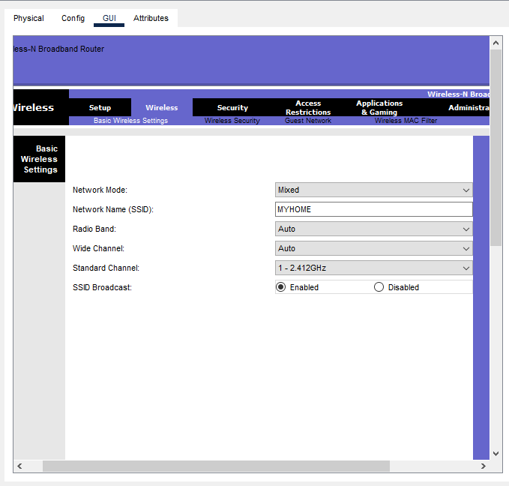
GO TO THE BOTTOM AND SAVE SETTINGS:

CLICK AT SECURITY KEY
SELECT WEP (Wired Equivalent Privacy. It’s a security protocol for wireless networks,)
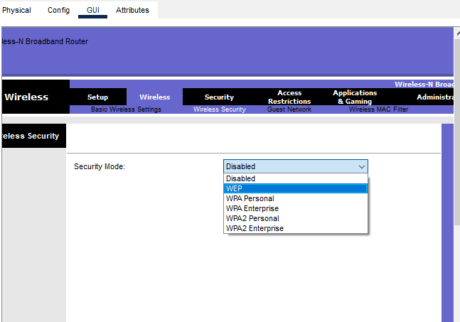
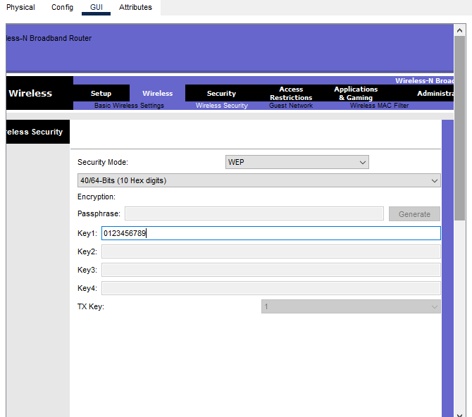
AND SAVE SETTINGS AFTER GIVING SECURITY KEY
AND THEN OPEN PCS AND GIVE STATIC IPS AND GATWWAYS
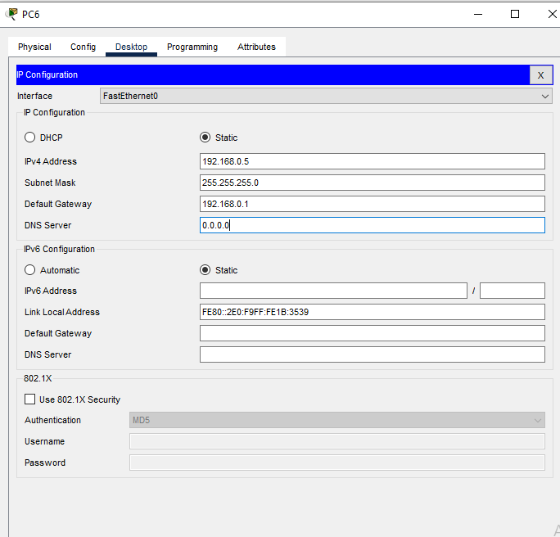
AND THEN CLICK AT PS AND WIRELESS NETWORK AND IT SHOWS THIS
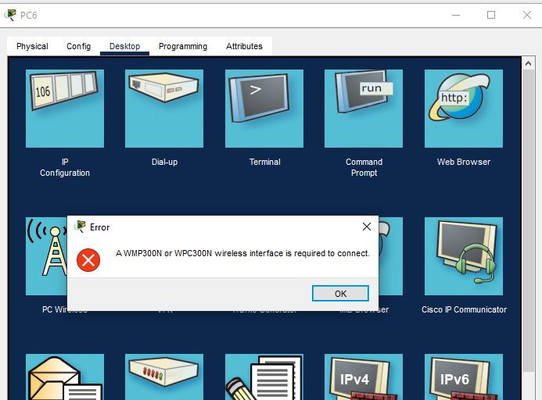
THEN CLICK AT PC PHYSICAL TURN OFF UTTON
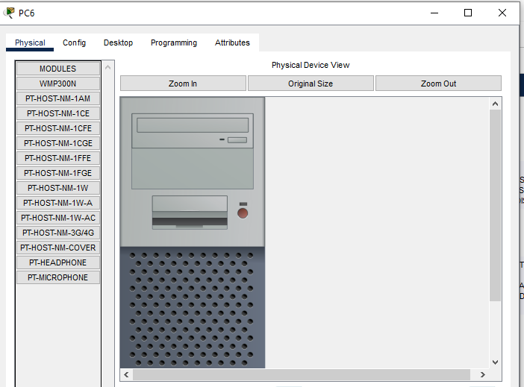
DRAG DOWN
AND DELET ALREDY EXISTING PORT AND ADD WMP300N AND CLICK AT ON BUTTON
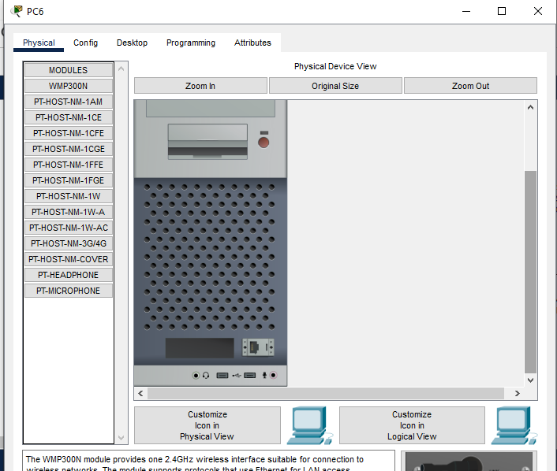
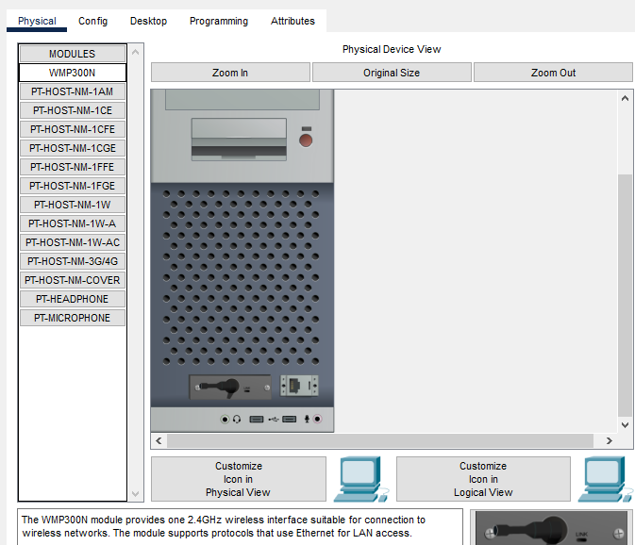
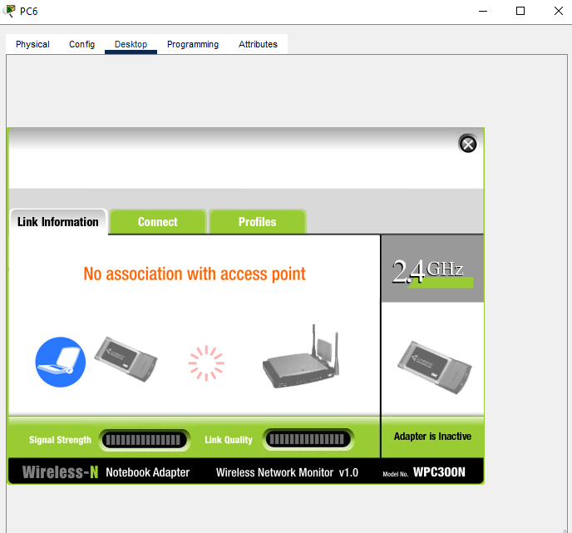CLICK AT CONNECT
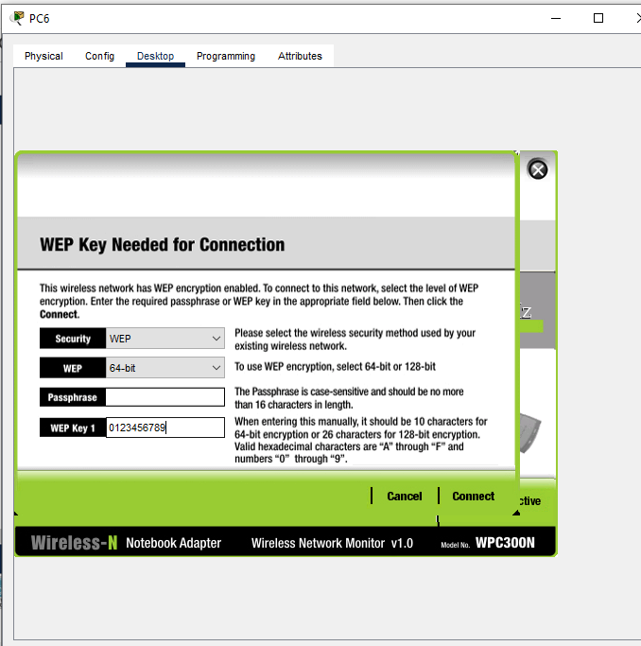
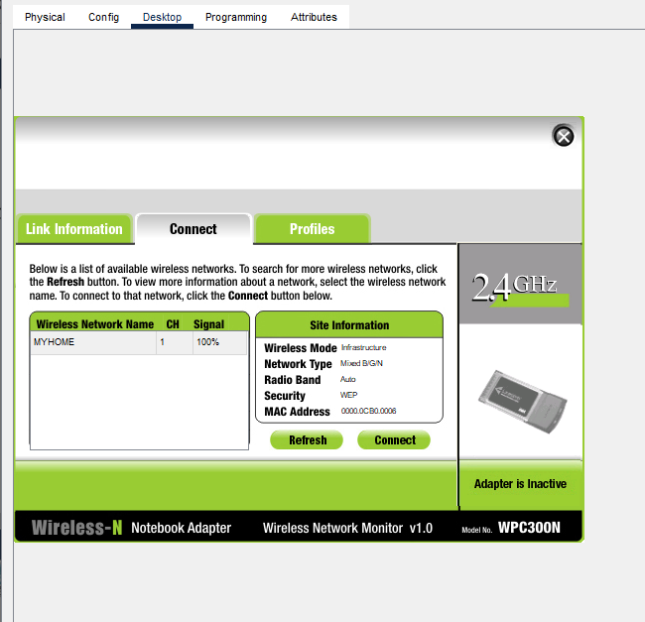
NOW ITS CONNECTED
